**Lab 4 – Total Order Sorting Report**

Net ID: tw2770

Name: Tzu-An Wang

1. TotalOrderSortMapper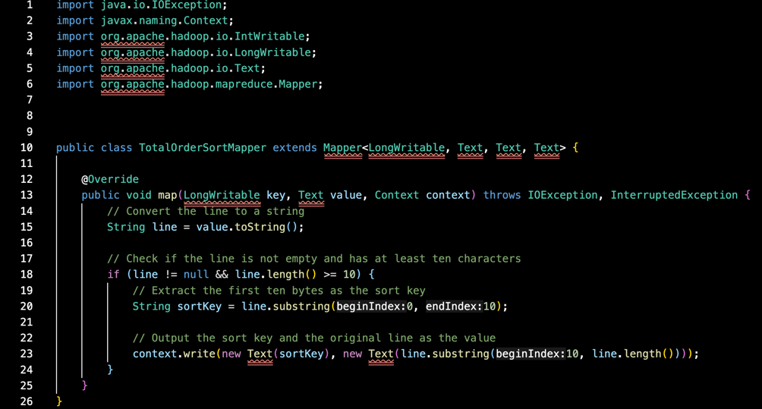
2. TotalOrderSortReducer

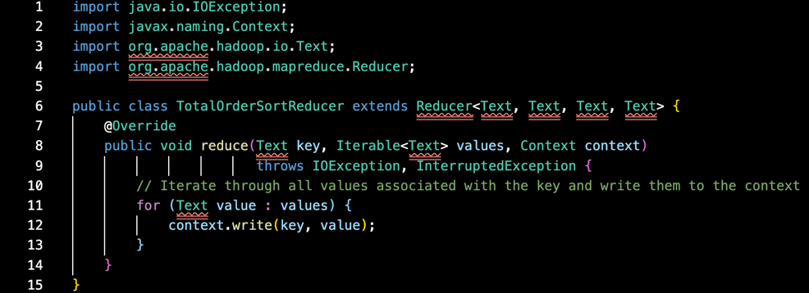

1. TotalOrderSort – Job 1

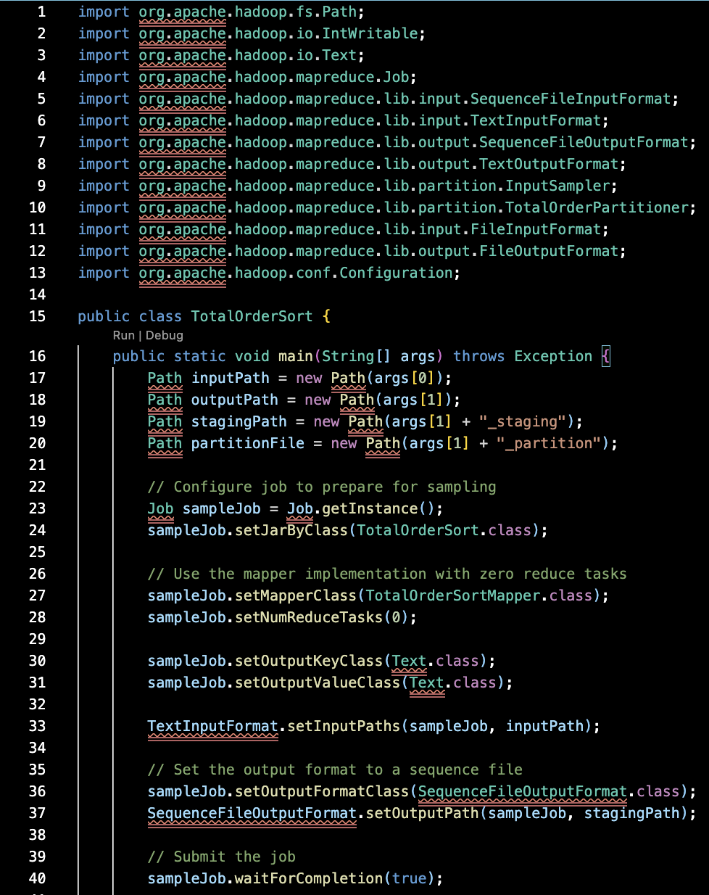

1. TotalOrderSort – Job 2

1. Program runs successfully

